

HLD: Azure-<Project Name>

April 20, 2021

Version Details:

|  |  |  |
| --- | --- | --- |
| Document: | Date | Version |
| Last Updated: | 18/04/2021 | 1.0 |
| Author: |  | |

Document History:

|  |  |  |  |  |
| --- | --- | --- | --- | --- |
| Version No. | Date | Summary | Peer Reviewed By | Author |
| v0.1 | 22/04/2021 | First draft |  |  |

Distribution & Sign-Off

|  |  |  |  |
| --- | --- | --- | --- |
| Sign Off | Role | Signature | Date |
|  |  |  |  |
|  |  |  |  |

|  |  |
| --- | --- |
| Distributed To | Role |
|  |  |
|  |  |
|  |  |

Table Of Content

1. Introduction 4

2. Project Summary 4

2.1. project scope and objectives 4

2.1.1. Objective 4

2.1.2. Interfaces in migration scope 4

2.2. Solution summary 5

2.2.1. Susiness AS-IS process (High-level) 5

2.2.2. business TO-BE PROCESS (Draft) 0

3. Azure application architecture 0

3.1. Detail Design 0

3.2. Application flow 0

4. Azure deployment & release model 0

5. Azure infrastructure & environment management 0

5.1. Azure Environment details 0

5.2. Azure Infrastructure design 0

5.3. Azure Infrastructure DESIGN: Network Topology Diagram 0

5.4. Azure Scalability & Reliability considerations 0

5.5. Azure Disaster recovery strategy 0

6. Azure identity and access management 0

7. Azure security considerations 0

8. Azure shared services 0

8.1. Azure Active Directory 0

8.2. Azure Alerting & Monitoring 0

8.3. Azure Log Analytics 0

8.4. Azure Key Vault 0

8.5. Azure Application Insight 0

8.6. Azure Cost Management 0

9. Risks/assumptions/dependencies 0

10. Support & bau process 0

11. Glossary 0

# Introduction

# Project Summary

## project scope and objectives

### Objective

### Interfaces in migration scope

## Solution summary

### Business AS-IS process (High-level)

### business TO-BE PROCESS (Draft)

# Azure application architecture

## Detail Design

## Application flow

# Azure deployment & release model

# Azure infrastructure & environment management

## Azure Environment details

## Azure Infrastructure design

## Azure Infrastructure DESIGN: Azure Network Topology Diagram

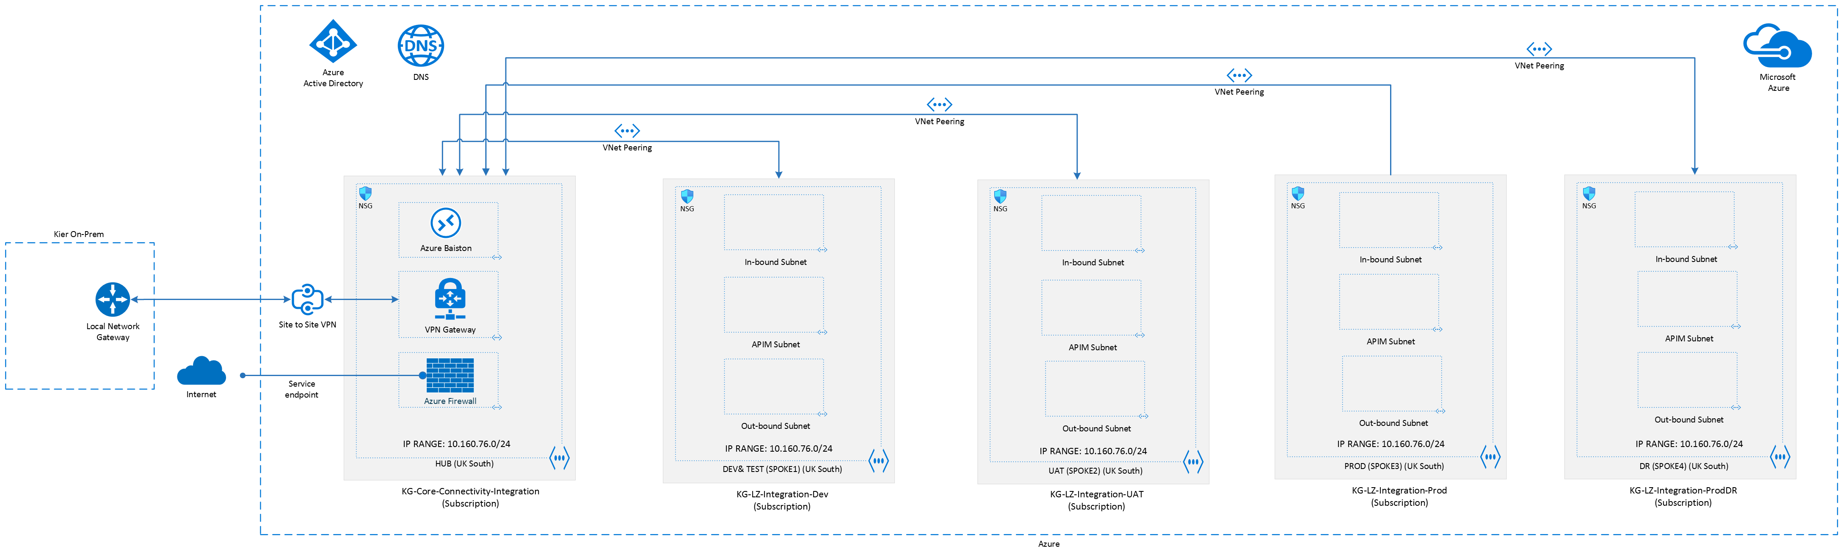

## Azure Scalability & Reliability considerations

## Azure Disaster recovery strategy

# Azure identity and access management

# Azure security considerations

# Azure shared services

## Azure Active Directory

## Azure Alerting & Monitoring

## Azure Log Analytics

## Azure Key Vault

## Azure Application Insight

## Azure Cost Management

# Risks/assumptions/dependencies

# Support & bau process

# Glossary

|  |  |
| --- | --- |
| Name | Definition |
|  |  |
|  |  |
|  |  |
|  |  |
|  |  |
|  |  |